**DAILY ONLINE ACTIVITIES SUMMARY**

|  |  |  |  |  |  |  |  |  |
| --- | --- | --- | --- | --- | --- | --- | --- | --- |
| **Date:** | **11-06-2020** | | | | | **Name:** | **Kavya** | |
| **Sem & Sec** | **6th & A** | | | | | **USN:** | **4al17cs041** | |
| **Online Test Summary** | | | | | | | | |
| **Subject** | | **--** | | | | | | |
| **Max. Marks** | | **--** | | **Score** | | | **--** | |
| **Certification Course Summary** | | | | | | | | |
| **Course** | **Learn Python With Google Colab** | | | | | | | |
| **Certificate Provider** | | | **Udemy** | | **Duration** | | | **2.5 Hours** |
| **Coding Challenges** | | | | | | | | |
| **Problem Statement:1.** Write a Java program to find the nodes which are at the maximum distance in a Binary Tree | | | | | | | | |
| **Status:Yes, I have uploaded all the programs.** | | | | | | | | |
| **Uploaded the report in Github** | | | | | **Yes** | | | |
| **If yes Repository name** | | | | | [**https://github.com/kavya-077/DAILY-STATUS**](https://github.com/kavya-077/DAILY-STATUS) | | | |
| **Uploaded the report in slack** | | | | | **Yes** | | | |

Online Test Details: (Attach the snapshot and briefly write the report for the same)

Certification Course Details: (Attach the snapshot and briefly write the report for the same)

**LEARN PYTHON WITH GOOGLE COLAB**

**LEARN PYTHON WITH GOOGLE COLAB**

**What we’ll learn**

* Basics of Python
* Data types
* Printing output
* If-Else conditions
* Looping using for, while
* Arithmatic operations
* Working with functions
* Working with List and Arrays
* Performing action on List
* Tuple, Set and Dictionary
* Working with packages
* Hands-on with Class

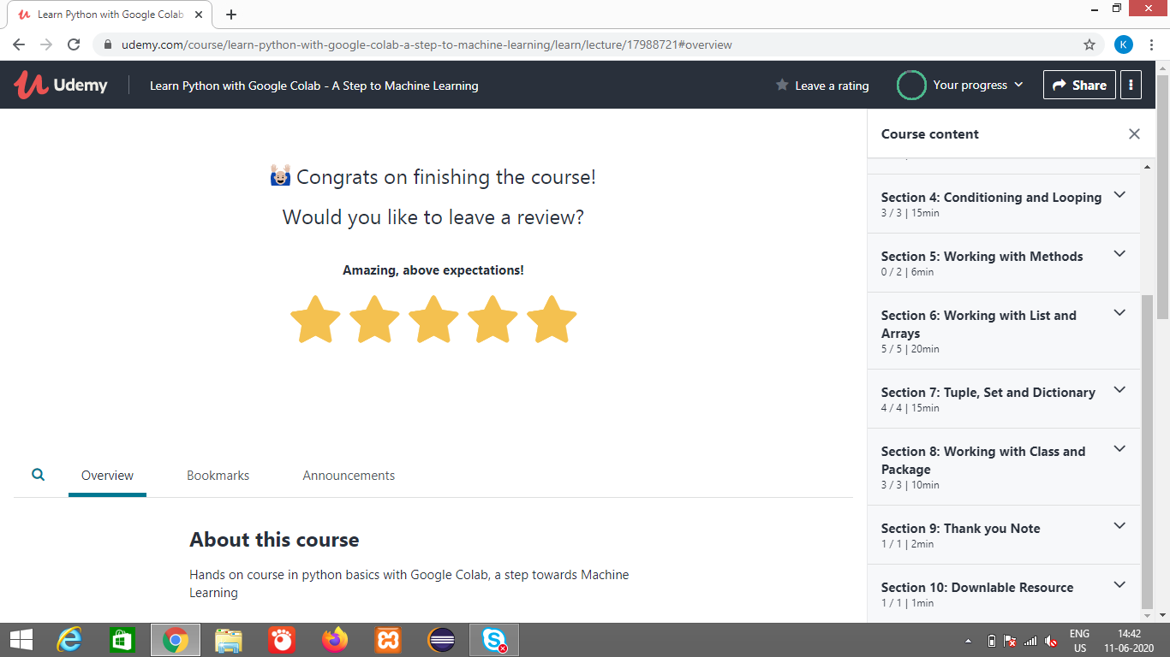

[**https://github.com/alvas-education-foundation/kavya-onlinecourse**](https://github.com/alvas-education-foundation/kavya-onlinecourse)

Coding Challenges Details: (Attach the snapshot and briefly write the report for the same)

[**https://github.com/alvas-education-foundation/kavya-OCA**](https://github.com/alvas-education-foundation/kavya-OCA)